Exp 5: Data Modelling and Form Design for a Business Application in Zoho Creator
Patient Appointment Booking Form

1. Aim
To design and build a functional “Patient Appointment Booking Form” application in Zoho Creator that demonstrates the correct usage of all thirteen Basic Fields available in the Form Builder, while solving a real hospital front-desk requirement of scheduling and pre-recording patient consultation requests.

2. Procedure

2.1 Problem Statement & Application Scope
A hospital currently accepts appointment requests over the phone or at the front desk, leading to double-booked consultation slots, no advance record of the patient's symptoms, and no way for doctors to prepare before the patient arrives. Walk-in patients often wait long hours because there is no prior scheduling system.
Design a low-code application using Zoho Creator that allows a patient to submit a consultation request through a single online form. The form must capture patient identity, contact details, referral information, symptom description, preferred appointment schedule, department, and consent for treatment — using every Basic Field type provided by Zoho Creator's Form Builder.

2.2 Data Model & ER Diagram
A Data Model consists of both the visual Entity-Relationship (ER) diagram showing schema relationships and the structured Data Dictionary table defining field types and constraints. The diagram below illustrates the internal schema for the Patient_Appointment_Booking_Form application: a PATIENT entity holding static personal details, an APPOINTMENT entity holding the transactional booking details, and a DEPARTMENT lookup entity referenced by the department drop-down.
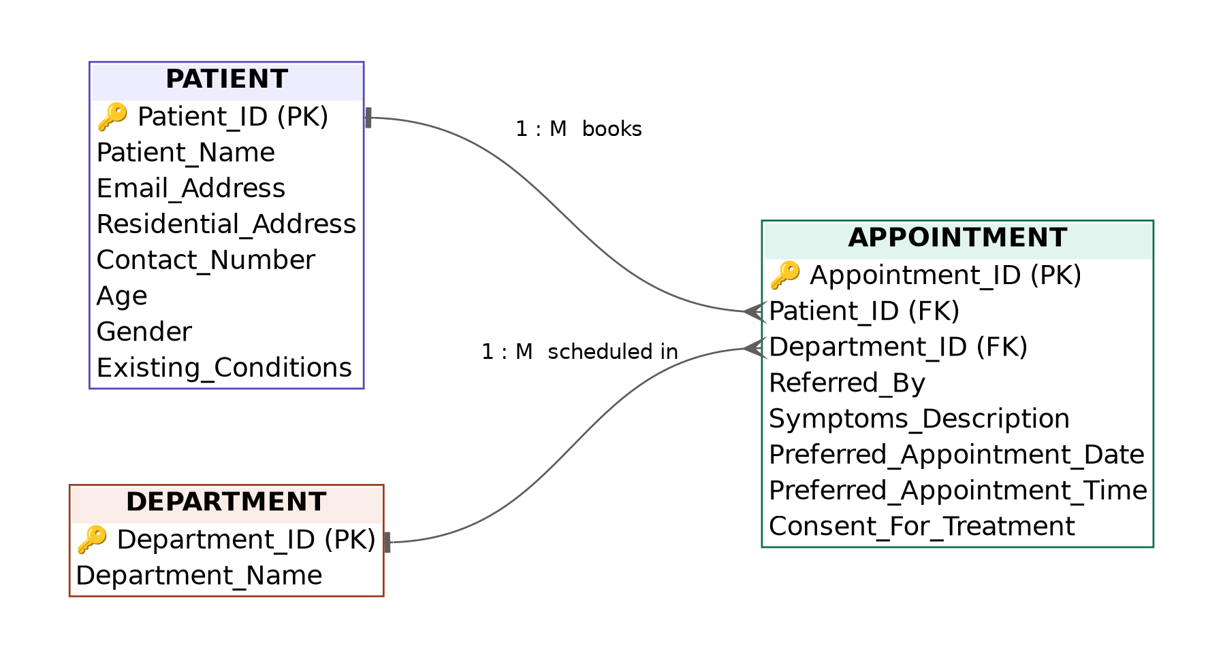
Figure 1: Entity-Relationship (ER) Schema Diagram for Patient Appointment Booking Form

2.3 Basic Fields Mapping & Data Dictionary
Table 1 presents the mapping of all thirteen Basic Fields from the Zoho Creator Form Builder palette to their specific roles, purpose, and sample values.
Basic Field | Field Link Name | Purpose & Validation Constraints | Sample Value
Name | Patient_Name | Captures the full name of the patient using First/Last name sub-fields (Mandatory). | Meera Krishnan
Email | Email_Address | Captures a validated email address for sending appointment confirmation. | meera.krishnan@example.com
Address | Residential_Address | Captures the patient's full residential address with city, state, and pincode. | 22, Nehru Street, Madurai, TN, 625001
Phone | Contact_Number | Captures a validated mobile number for the clinic to call and confirm the appointment. | +91 98400 11223
Single Line | Referred_By | Captures a short free-text entry for a referring doctor or source of referral. | Dr. S. Balaji, General Physician
Multi Line | Symptoms_Description | Captures free-text description of the patient's current symptoms or reason for visit. | Persistent headache and mild fever for the past 3 days.
Number | Age | Captures a numeric value with validation for the patient's age. | 34
Date | Preferred_Appointment_Date | Captures the patient's preferred date of consultation using a date picker. | 05-Aug-2026
Time | Preferred_Appointment_Time | Captures the patient's preferred time slot for the consultation. | 10:30 AM
Drop Down | Department | Presents a single-select list of hospital departments/specializations. | General Medicine
Radio | Gender | Captures a single mandatory selection among mutually exclusive options. | Female
Multi Select | Existing_Conditions | Allows selection of one or more pre-existing medical conditions or allergies. | Diabetes, Allergy to Penicillin
Checkbox | Consent_For_Treatment | Captures the patient's consent to proceed with examination and treatment. | Checked (Agreed)

2.4 Form Layout & Configuration Steps
The Patient_Appointment_Booking_Form was organized into four logical, patient-friendly sections:
Section A — Patient Details: Patient Name (Name), Age (Number), Gender (Radio).
Section B — Contact Details: Email Address (Email), Contact Number (Phone), Residential Address (Address).
Section C — Consultation Details: Referred By (Single Line), Symptoms Description (Multi Line), Department (Drop Down), Existing Conditions (Multi Select).
Section D — Scheduling & Consent: Preferred Appointment Date (Date), Preferred Appointment Time (Time), Consent For Treatment (Checkbox).
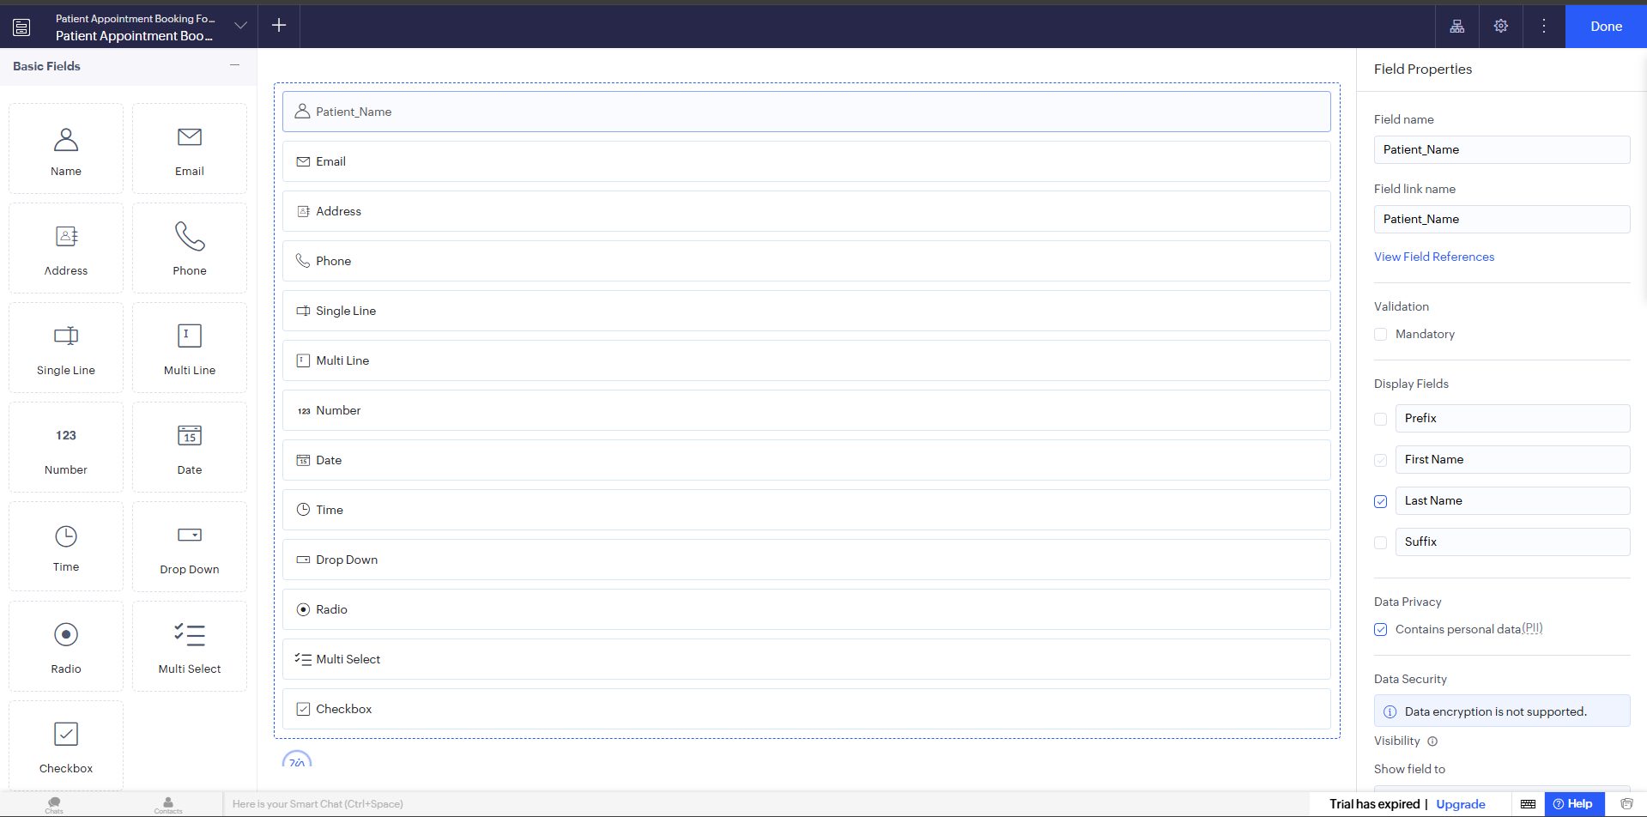
Figure 2: Form Builder Workspace & Field Properties Inspector Setup in Zoho Creator

2.5 Workflow Scripting Configuration
Deluge validation scripts were configured under Workflows > Form Workflows > Validations on form submission to enforce business logic checks for a valid patient age, non-past preferred appointment dates, and mandatory treatment consent before the request can be submitted.
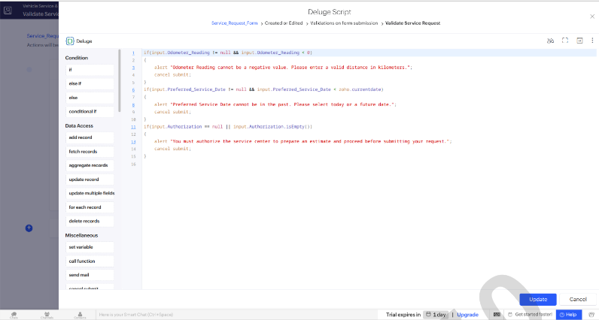
Figure 3: Deluge Workflow Scripting Canvas (Validate Appointment Request — On Validate Event)

3. Output
The following figures show the live preview of the form and submitted patient records in the report view:
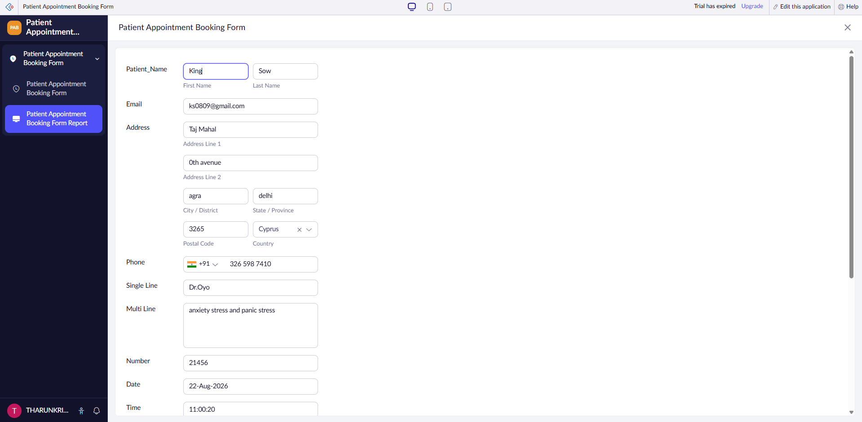
Figure 4: Live Application Runtime Preview for Patient_Appointment_Booking_Form Entry
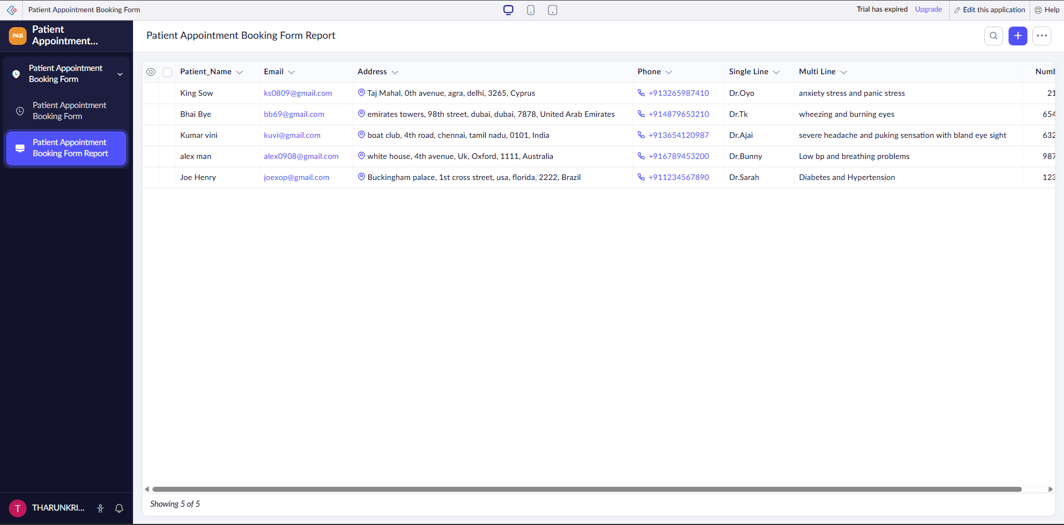
Figure 5: Patient_Appointment_Booking_Form_Report View Displaying Submitted Patient Records

4. Result
The “Patient Appointment Booking Form” application was successfully built in Zoho Creator using all thirteen Basic Fields, with full field validations, section layout formatting, ER schema modeling, and report view generation meeting all assignment requirements.

